**Attrition Assignments**

**Step1: Launcing :**

**import pandas as pd**

**import matplotlib.pyplot as plt**

**import numpy as np**

**dataset=pd.read_csv("general_data.csv")**

**dataset.head()**

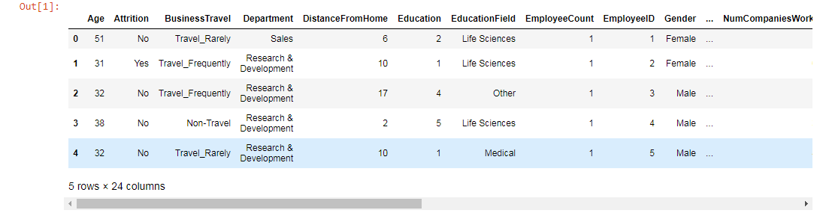

**dataset.columns**

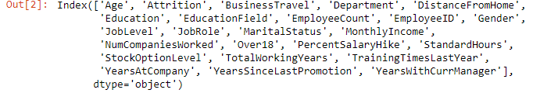

**Dataset**

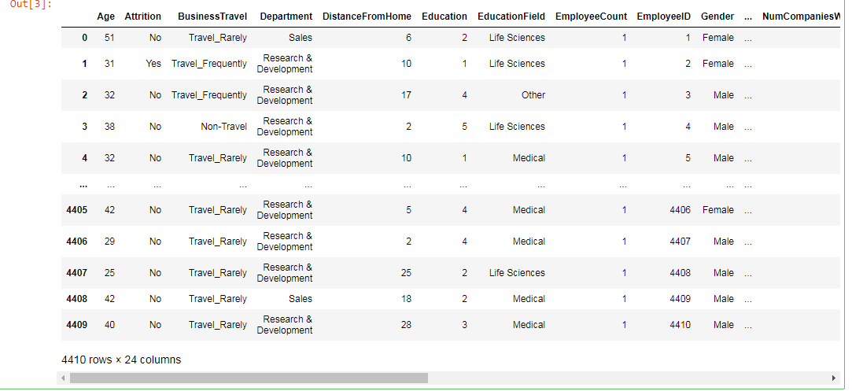

**dataset.isnull()**

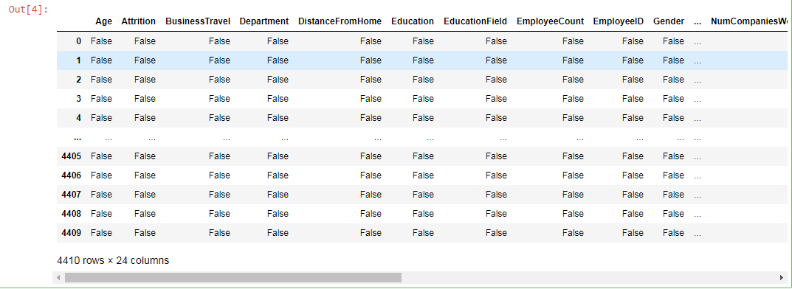

**dataset.info()**

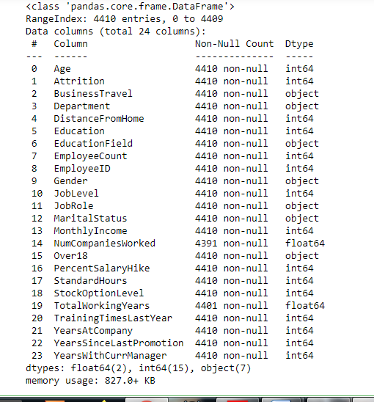

**dataset.duplicated()**

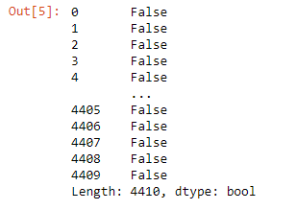

**dataset.drop_duplicates()**

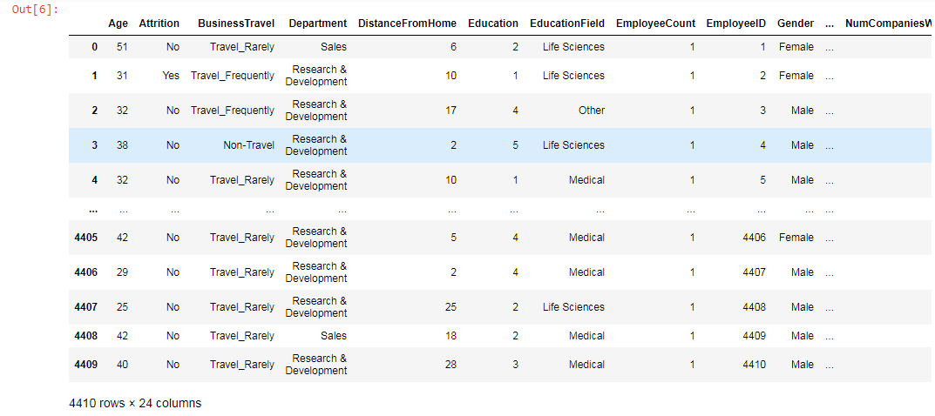

**dataset2=dataset[['Age', 'Attrition', 'BusinessTravel', 'Department', 'DistanceFromHome',**

**'Education', 'EducationField', 'EmployeeCount', 'EmployeeID', 'Gender',**

**'JobLevel', 'JobRole', 'MaritalStatus', 'MonthlyIncome',**

**'NumCompaniesWorked', 'Over18', 'PercentSalaryHike', 'StandardHours',**

**'StockOptionLevel', 'TotalWorkingYears', 'TrainingTimesLastYear',**

**'YearsAtCompany', 'YearsSinceLastPromotion', 'YearsWithCurrManager']].describe()**



**dataset3=dataset[['Age', 'Attrition', 'BusinessTravel', 'Department', 'DistanceFromHome',**

**'Education', 'EducationField', 'EmployeeCount', 'EmployeeID', 'Gender',**

**'JobLevel', 'JobRole', 'MaritalStatus', 'MonthlyIncome',**

**'NumCompaniesWorked', 'Over18', 'PercentSalaryHike', 'StandardHours',**

**'StockOptionLevel', 'TotalWorkingYears', 'TrainingTimesLastYear',**

**'YearsAtCompany', 'YearsSinceLastPromotion', 'YearsWithCurrManager']].median()**

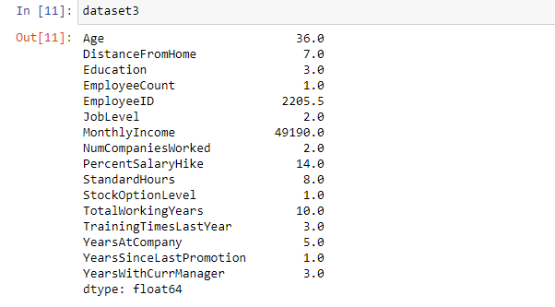

**dataset4=dataset[['Age', 'Attrition', 'BusinessTravel', 'Department', 'DistanceFromHome',**

**'Education', 'EducationField', 'EmployeeCount', 'EmployeeID', 'Gender',**

**'JobLevel', 'JobRole', 'MaritalStatus', 'MonthlyIncome',**

**'NumCompaniesWorked', 'Over18', 'PercentSalaryHike', 'StandardHours',**

**'StockOptionLevel', 'TotalWorkingYears', 'TrainingTimesLastYear',**

**'YearsAtCompany', 'YearsSinceLastPromotion', 'YearsWithCurrManager']].mode()**

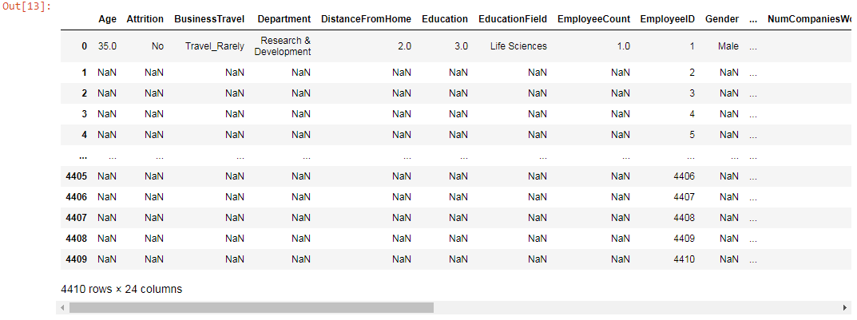

**dataset[['Age', 'Attrition', 'BusinessTravel', 'Department', 'DistanceFromHome',**

**'Education', 'EducationField', 'EmployeeCount', 'EmployeeID', 'Gender',**

**'JobLevel', 'JobRole', 'MaritalStatus', 'MonthlyIncome',**

**'NumCompaniesWorked', 'Over18', 'PercentSalaryHike', 'StandardHours',**

**'StockOptionLevel', 'TotalWorkingYears', 'TrainingTimesLastYear',**

**'YearsAtCompany', 'YearsSinceLastPromotion', 'YearsWithCurrManager']].mean()**

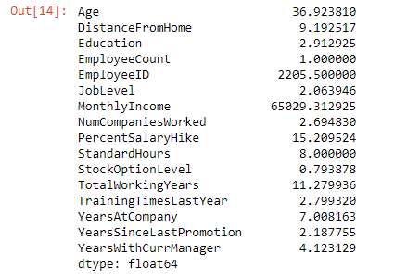

**dataset[['Age', 'Attrition', 'BusinessTravel', 'Department', 'DistanceFromHome',**

**'Education', 'EducationField', 'EmployeeCount', 'EmployeeID', 'Gender',**

**'JobLevel', 'JobRole', 'MaritalStatus', 'MonthlyIncome',**

**'NumCompaniesWorked', 'Over18', 'PercentSalaryHike', 'StandardHours',**

**'StockOptionLevel', 'TotalWorkingYears', 'TrainingTimesLastYear',**

**'YearsAtCompany', 'YearsSinceLastPromotion', 'YearsWithCurrManager']].var()**

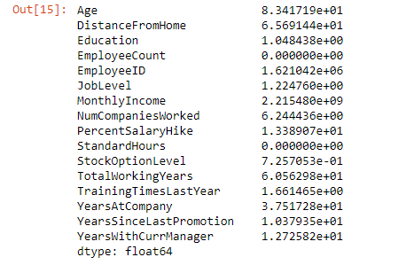

**dataset[['Age', 'Attrition', 'BusinessTravel', 'Department', 'DistanceFromHome',**

**'Education', 'EducationField', 'EmployeeCount', 'EmployeeID', 'Gender',**

**'JobLevel', 'JobRole', 'MaritalStatus', 'MonthlyIncome',**

**'NumCompaniesWorked', 'Over18', 'PercentSalaryHike', 'StandardHours',**

**'StockOptionLevel', 'TotalWorkingYears', 'TrainingTimesLastYear',**

**'YearsAtCompany', 'YearsSinceLastPromotion', 'YearsWithCurrManager']].skew()**

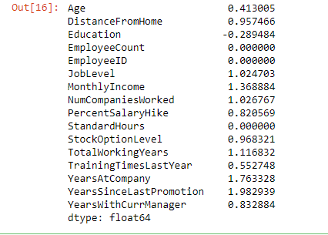

**dataset[['Age', 'Attrition', 'BusinessTravel', 'Department', 'DistanceFromHome',**

**'Education', 'EducationField', 'EmployeeCount', 'EmployeeID', 'Gender',**

**'JobLevel', 'JobRole', 'MaritalStatus', 'MonthlyIncome',**

**'NumCompaniesWorked', 'Over18', 'PercentSalaryHike', 'StandardHours',**

**'StockOptionLevel', 'TotalWorkingYears', 'TrainingTimesLastYear',**

**'YearsAtCompany', 'YearsSinceLastPromotion', 'YearsWithCurrManager']].kurt()**

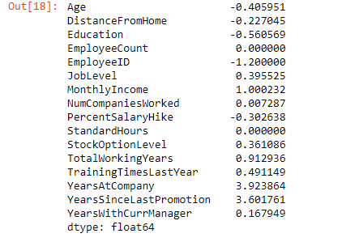

**dataset[['Age', 'DistanceFromHome','Education', 'EmployeeCount', 'EmployeeID',**

**'JobLevel', 'MonthlyIncome','NumCompaniesWorked', 'PercentSalaryHike', 'StandardHours',**

**'StockOptionLevel', 'TotalWorkingYears', 'TrainingTimesLastYear',**

**'YearsAtCompany', 'YearsSinceLastPromotion', 'YearsWithCurrManager']].sum()**

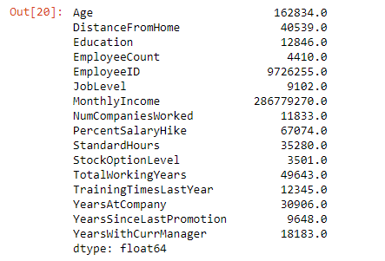

**dataset[['Age', 'DistanceFromHome','Education', 'EmployeeCount', 'EmployeeID',**

**'JobLevel', 'MonthlyIncome','NumCompaniesWorked', 'PercentSalaryHike', 'StandardHours',**

**'StockOptionLevel', 'TotalWorkingYears', 'TrainingTimesLastYear',**

**'YearsAtCompany', 'YearsSinceLastPromotion', 'YearsWithCurrManager']].std()**

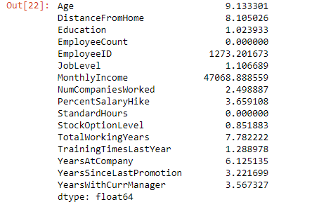

**plt.boxplot(dataset.Age)**

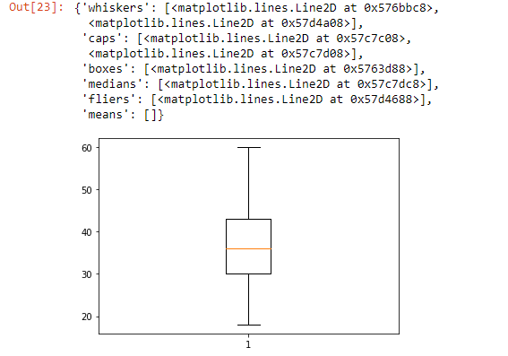

**plt.boxplot(dataset.Education)**

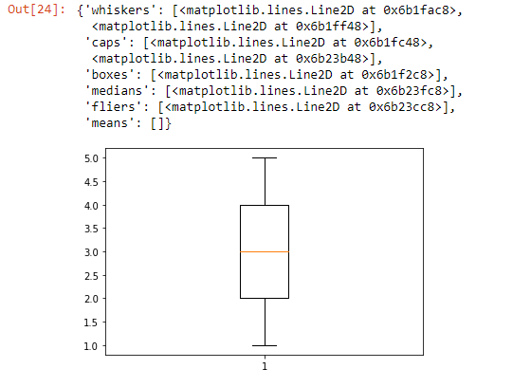

**plt.boxplot(dataset.MonthlyIncome)**

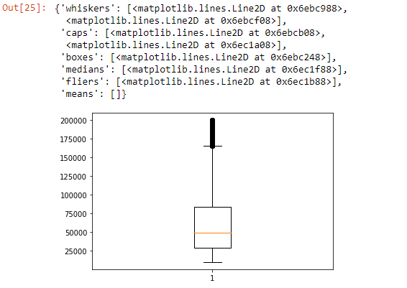

**plt.boxplot(dataset.YearsAtCompany)**

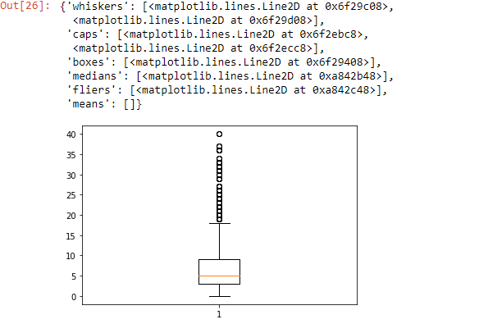

**plt.hist(dataset.MonthlyIncome)**

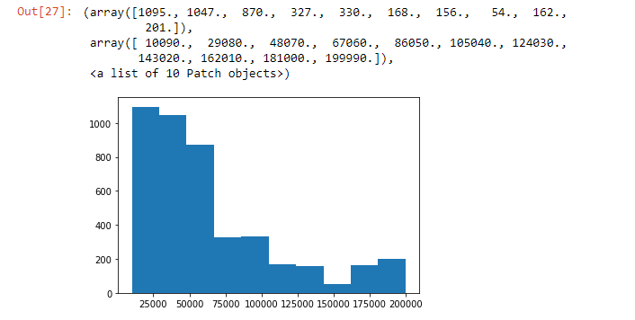

**# Attrition with some other fields:**

**dataset["Attrition"]=dataset["Attrition"].map({"Yes":1,"No":0})**

**dataset.head()**

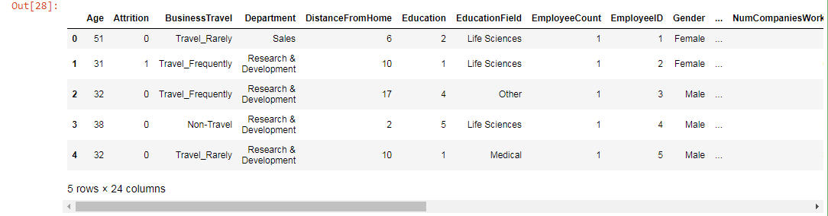

**Check for Hypothesis:**

**import pandas as pd**

**dataset_yes= pd.read_excel('general_data.xlsx',sheet_name="Attrition_Yes")**

**dataset_no= pd.read_excel('general_data.xlsx',sheet_name="Attrition_No")**

**from scipy.stats import mannwhitneyu**

**stats,p = mannwhitneyu(dataset_yes.Age, dataset_no.Age)**

**print("Stats=",stats,"And P=",p)**

**if p<0.05:**

**print("Hypothesis is rejectected.")**

**else:**

**print("Alternate hypothesis accepted")**

Stats= 252760.5 And P= 8.533914665285945e-273

Hypothesis is rejectected.

**# Attrition with income**

**stats,p = mannwhitneyu(dataset_yes.PercentSalaryHike, dataset_no.PercentSalaryHike)**

**print("Stats=",stats,"And P=",p)**

**if p<0.05:**

**print("Hypothesis is rejectected.")**

**else:**

**print("Alternate hypothesis accepted")**

Stats= 273787.5 And P= 5.0375111124363596e-263

Hypothesis is rejectected.

**# Attrition with Distance fromHome**

**stats,p = mannwhitneyu(dataset_yes.DistanceFromHome, dataset_no.DistanceFromHome)**

**print("Stats=",stats,"And P=",p)**

**if p<0.05:**

**print("Hypothesis is rejectected.")**

**else:**

**print("Alternate hypothesis accepted")**

Stats= 273787.5 And P= 5.0375111124363596e-263

Hypothesis is rejectected.

**stats,p = mannwhitneyu(dataset_yes.YearsWithCurrManager, dataset_no.YearsWithCurrManager)**

**print("Stats=",stats,"And P=",p)**

**if p<0.05:**

**print("Hypothesis is rejectected.")**

**else:**

**print("Alternate hypothesis accepted")**

Stats= 273052.5 And P= 2.3104478144262257e-263

Hypothesis is rejectected.

**# Chi square test:**

**dataset1=pd.read_csv("general_data.csv")**

**from scipy.stats import chi2_contingency**

**chitable=pd.crosstab(dataset1.Gender,dataset.TotalWorkingYears)**

**chitable**

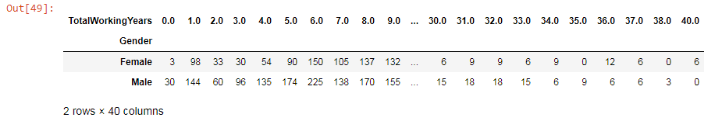

**Statistical test:**

**from scipy.stats import ttest_ind**

**stats,p=ttest_ind(dataset_yes.YearsWithCurrManager, dataset_no.YearsWithCurrManager)**

**print(stats,p)**

-37.694238548131764 6.582076911148772e-271

**stats,p=ttest_ind(dataset_yes.MonthlyIncome, dataset_no.MonthlyIncome)**

**print(stats,p)**

-1623.8364867084538 0.0

**stats,p=ttest_ind(dataset_yes.YearsAtCompany, dataset_no.YearsAtCompany)**

**print(stats,p)**

-37.694238548131764 6.582076911148772e-271

**# Correlation,Unsupervised Learning:**

**from scipy.stats import pearsonr**

**stats,p=pearsonr(dataset.Attrition,dataset.Age)**

**print(stats,p)**

-0.15920500686577965 1.996801615886744e-26

**stats,p=pearsonr(dataset.Attrition,dataset.DistanceFromHome)**

**print(stats,p)**

-0.009730141010179674 0.5182860428050771

**stats,p=pearsonr(dataset.Attrition,dataset.JobLevel)**

**print(stats,p)**

-0.010289713287495042 0.49451717271828405

**stats,p=pearsonr(dataset.Attrition,dataset.PercentSalaryHike)**

**print(stats,p)**

0.03253259489105349 0.030743386433355353

**stats,p=pearsonr(dataset.YearsAtCompany,dataset.YearsAtCompany)**

**print(stats,p)**

1.0 0.0